Overview:

The purpose of this analysis is to create a tool that can help Alphabet Soup select funding applicants for the best chance of venture success. We will use machine learning and neural networks and their features to create a binary classifier that can predict whether applicants will be successful if funded by Alphabet Soup.

Results:

* Data Preprocessing
  + What variable(s) are the target(s) for your model?  
    **“IS_SUCCESSFUL” is the target variable**
  + What variable(s) are the features for your model?  
    **Feature variables are the other columns from the application data frame.**
  + What variable(s) should be removed from the input data because they are neither targets nor features?  
    **“NAME” and “EIN”**
* Compiling, Training, and Evaluating the Model
  + How many neurons, layers, and activation functions did you select for your neural network model, and why?  
    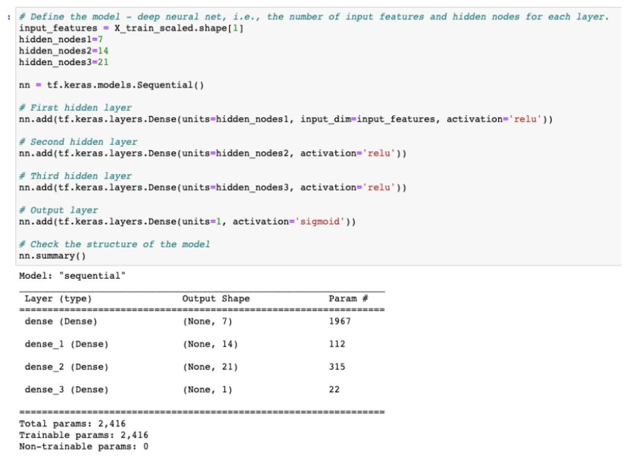  
    **Performance was upgraded to 78% when adding a third layer.**
  + Were you able to achieve the target model performance?  
    **Yes**
  + What steps did you take in your attempts to increase model performance?  
    **Adding in a third layer**

Summary:

I would recommend using more than 2 layers to achieve better performance.